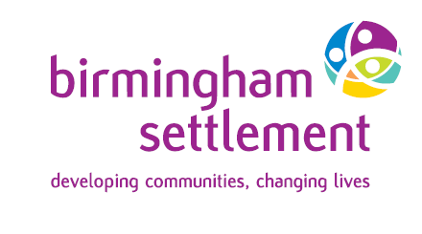

www.birminghamsettlement.org.uk

Since 1899, Birmingham Settlement has been working to create opportunity and choice – connecting and empowering people through action, activities, and shared learning to build and sustain wellbeing for all.

Debt & Welfare Benefits Adviser
Salary: £29,063 pa
35 hours per week, 25 days A/L + contributory pension scheme

Birmingham Settlement has an opportunity to join our Money Advice Team, as an experienced Debt & Welfare Benefits Adviser.
As an experienced Debt & Welfare Benefits Adviser you will already have a background in providing effective, high-quality debt and welfare benefits advice to a wide range of clients in differing circumstance.
Based at our Newtown office with outreach work in other areas of the city, you will be adaptable with excellent communication skills, flexibility, and the ability to manage your own workload.
You will be joining a long established and professional Money Advice Team providing specialist advice with a holistic approach that covers all areas of debt and welfare benefit along with training to build and continually improve money management and financial capability.

This is a great opportunity to join a progressive charity making a real difference to people’s lives – see our website www.birminghamsettlement.org.uk
For an informal discussion about the roles call Theresa Gniadkowski on 0121 250 0770
For an application pack visit our website Vacancies | Birmingham Settlement
or email: recruitment@bsettlement.org.uk or write to Human Resources, Birmingham Settlement – Sports & Community Centre, 600 Kingstanding Road, Kingstanding, Birmingham, B44 9SH

Closing date for applications: Monday,28/07/2025 at 5pm
Interviews: w/c Monday, 4/08/2025

Birmingham Settlement is committed to Equality of Opportunity and welcomes applications from all sections of the community. Registered charity number 517303

